Hyphenated Compound Noun

🔹 What is Hyphenated Compound Noun
# Source: AI Source: Provided by: [Data Path: Persons Table -> ID Column: 1, Name_En Column: Motasem Essam] -> From: [Chatgpt (GPT-4-turbo)] on [7/26/2025]
A hyphenated compound noun is made up of two or more words that are joined together using hyphens (-) to form a single noun.
✨ The hyphen connects the words so that they act as one noun with a combined meaning.

✅ Definition:
# Source: AI Source: Provided by: [Data Path: Persons Table -> ID Column: 1, Name_En Column: Motasem Essam] -> From: [Chatgpt (GPT-4-turbo)] on [7/26/2025]
Hyphenated compound nouns are compound nouns that are linked with hyphens and function as a single unit (noun).

📚 Examples of Hyphenated Compound Nouns:
# Source: AI Source: Provided by: [Data Path: Persons Table -> ID Column: 1, Name_En Column: Motasem Essam] -> From: [Chatgpt (GPT-4-turbo)] on [7/26/2025]
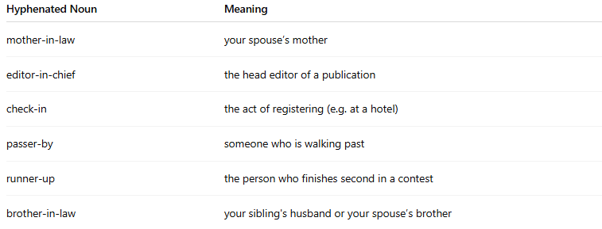
Hyphenated Noun | Meaning
mother-in-law | your spouse’s mother
editor-in-chief | the head editor of a publication
check-in | the act of registering (e.g. at a hotel)
passer-by | someone who is walking past
runner-up | the person who finishes second in a contest
brother-in-law | your sibling's husband or your spouse’s brother

📝 Example Sentences:
# Source: AI Source: Provided by: [Data Path: Persons Table -> ID Column: 1, Name_En Column: Motasem Essam] -> From: [Chatgpt (GPT-4-turbo)] on [7/26/2025]
- My mother-in-law is visiting us today.
- The check-in process at the airport was quick.
- The runner-up still received a prize.
- A passer-by called the police after the accident.

✅ Hyphen Use:
# Source: AI Source: Provided by: [Data Path: Persons Table -> ID Column: 1, Name_En Column: Motasem Essam] -> From: [Chatgpt (GPT-4-turbo)] on [7/26/2025]
Hyphens are often used in compound nouns when:
- The word combination is customary in English spelling
- It clarifies meaning
- It avoids confusion or awkwardness (e.g., “man-eating shark” vs. “man eating shark”)

🔁 Related Comparison:
# Source: AI Source: Provided by: [Data Path: Persons Table -> ID Column: 1, Name_En Column: Motasem Essam] -> From: [Chatgpt (GPT-4-turbo)] on [7/26/2025]
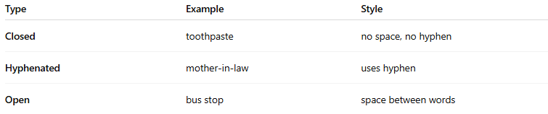
Type | Example | Style
Closed | toothpaste | no space, no hyphen
Hyphenated | mother-in-law | uses hyphen
Open | bus stop | space between words

✅ Summary:
# Source: AI Source: Provided by: [Data Path: Persons Table -> ID Column: 1, Name_En Column: Motasem Essam] -> From: [Chatgpt (GPT-4-turbo)] on [7/26/2025]
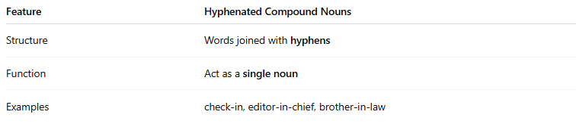
Feature | Hyphenated Compound Nouns
Structure | Words joined with hyphens
Function | Act as a single noun
Examples | check-in, editor-in-chief, brother-in-law

